

Python

Lab

Tutorial

Class IX

Lab 12

1. Go to <https://www.tynker.com/>

Click on join for free

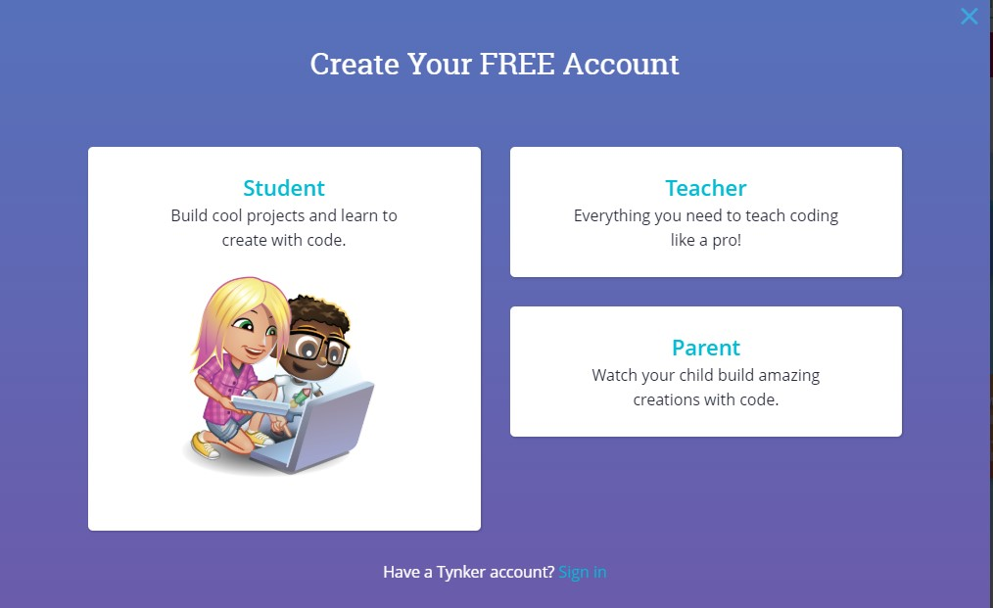Open account as a student

Give your gmail to registration

Put your age and you will get a dashboard

Click on code commander to play game. You will learn python and JavaScript programming language by playing games.

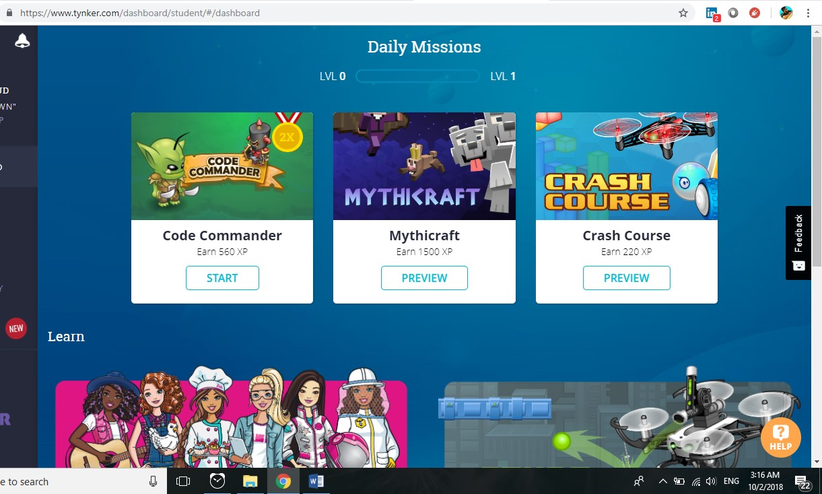

Attack the enemy. Kill them all and complete 10 levels of Code Commander.

